SIMULATION OF PEDAL POWER MOBILE PHONE CHARGER (PPMPC) SUPPORT

Description
- The support is constructed from a tubular frame with dimensions 40 × 40 × 4 mm. It includes a special bolt, which measures 150 mm in length and has a diameter of 13 mm.
- The overall height of the support is 220 mm, and the mass of the simplified model is approximately 1.6 g.
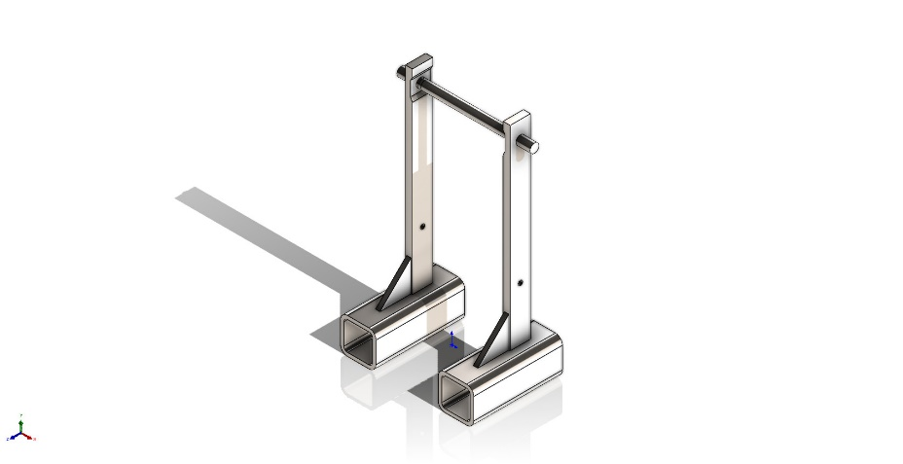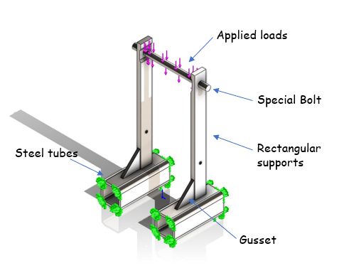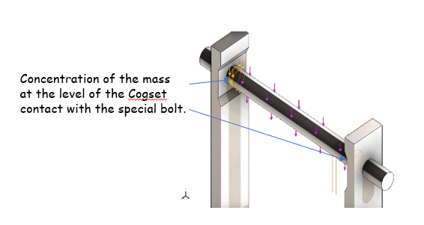

Fig I: Description of PPMPC

Assumptions
- It was hypothesized that as power output increases, the weight distribution would shift towards the bottom bracket and away from the saddle. This was hypothesized because in order to increase power, the forces on the crank must necessarily increase with power output because cadence and crank length are held constant. It is assumed that this increase in forces will come from a shift in body weight forces from the saddle and/or stem as total forces must sum to one body weight. It was also hypothesized that forces on the handlebars would increase as power output increased due to changes in rider posture on the bike.
- It was also assumed that 60 % of the mass of the rider is distributed to the back wheel during normal sitting position.
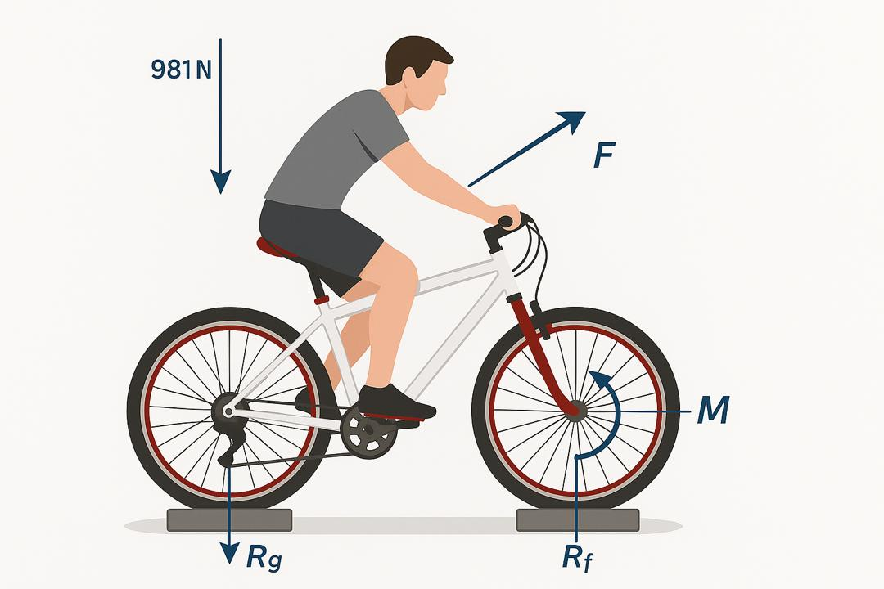
Fig II: Force distribution for a 100kg body(rider).

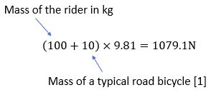
$$\frac{60}{100}×1079.1=647.46N$$
- Now we take into consideration that during riding the cyclist induces cyclic forces which affects the support and also that the position of the cyclist on the bicycle may vary with fatigue so we took an approximation of 20kg additional mass which will compensate any varying in position.
$$647.66+196.2=843.86N$$

Applied Loads
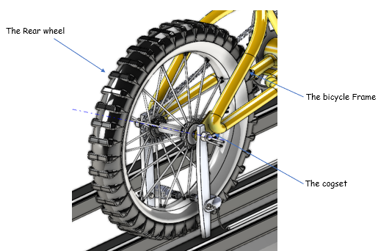
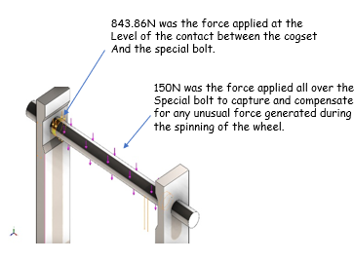
Fig III: Loads applied on the support.

Analysis of results

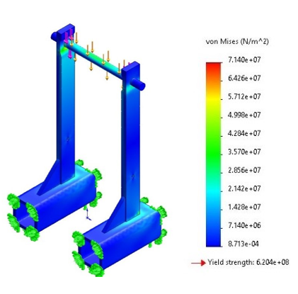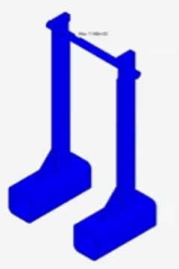
Fig. IV: Von Mises Stress.
The finite element analysis (FEA) of the structural frame indicates that the maximum von Mises stress experienced within the structure is approximately 71.4 MPa, significantly lower than the material’s yield strength of 620 MPa. This results in a high factor of safety of approximately 8.7, confirming that the structure remains well within the elastic range under the given loading conditions. The structure is therefore considered mechanically safe.
References
- Crahalios, A. (2015). An analysis of the bicycle-rider interface forces in stationary road cycling (Master’s thesis). University of Colorado, Department of Integrative Physiology. (Original B.S., University of Portland, 2011), pp. 12–15.

